Lista de Compras

Producto | Cantidad | Precio | Tienda | Pais
SEN-09268  IMU Analog Combo Board - 5 Degrees of Freedom IDG500/ADXL335  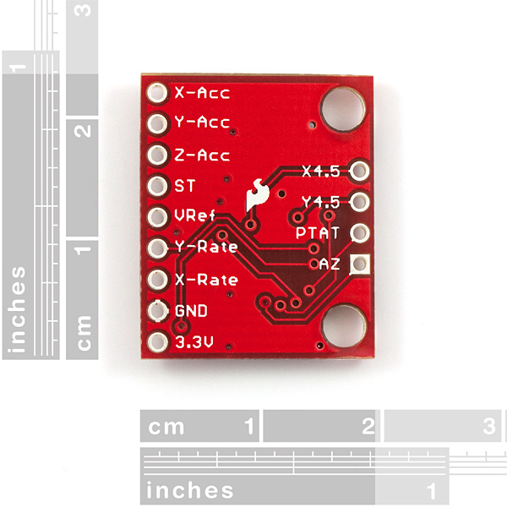 | 1 | $44.95 | Sparkfun | EEUU
ROB-09670  Motor Driver 2A Dual L298 H-Bridge  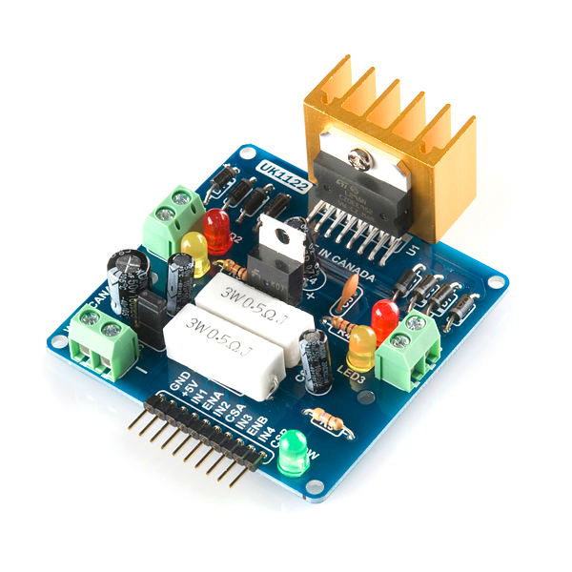 | 1 | $34.95 | Sparkfun | EEUU
ROB-10335  Pan/Tilt Bracket  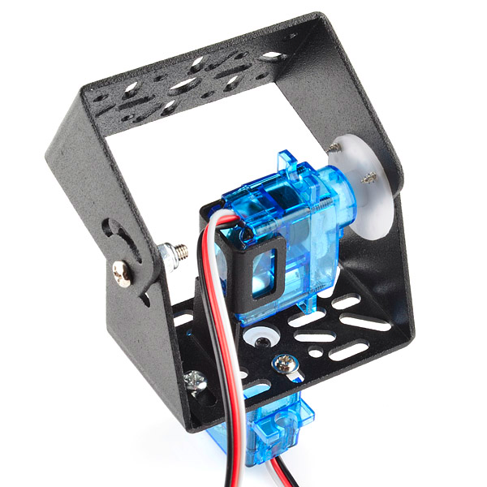 | 1 | $5.95 | Sparkfun | EEUU
ROB-00421  Toy Tires - Sport  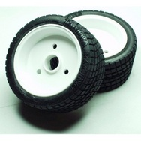 | 1 | $6.95 | Sparkfun | EEUU
ROB-09065  Servo - Small  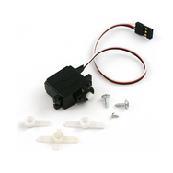 | 4 | $35.80 | Sparkfun | EEUU
PIC32-Pinguino-OTG  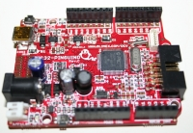 | 1 | 29.90€ | Pinguino.cc | Francia
Lynxmotion 12VDC 253RPM 138.9oz-in GHM-12 Spur Gear Head Motor  Product code :  RB-Lyn-35  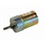 | 2 | $59.90 | Robotshop | EEUU
Lynxmotion HUB-02 Universal Hub - 6mm (pair)  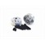 | 1 | $8.40 | Robotshop | EEUU
Parallax 7.2V Motor, Bracket and Wheel Kit (Pair)  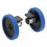 | 1 | $85.59 | Robotshop | EEUU
Lynxmotion Sumo Tire (pair)  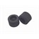 | 1 | $15.78 | Robotshop | EEUU
Turnigy 3600mAh 5S 30C Lipo Pack  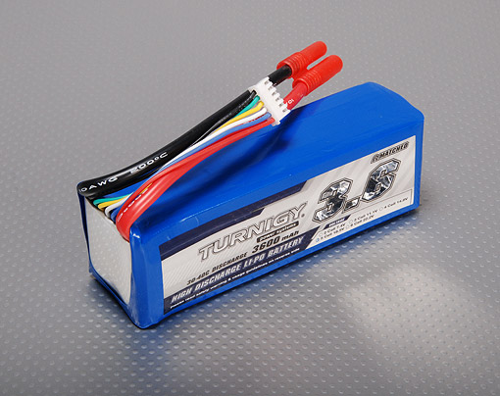 | 2 | 92.04 | Hobby King | EEUU
Battery Monitor 2-6S  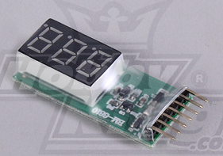 | 2 | $4 | Hobby King | EEUU
IMAX B6 Charger/Discharger 1-6 Cells (GENUINE)  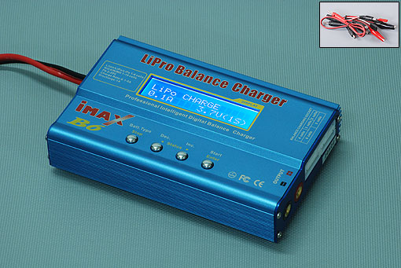 | 1 | $24.99 | Hobby King | EEUU
Lithium Polymer Charge Pack 18x22cm Sack  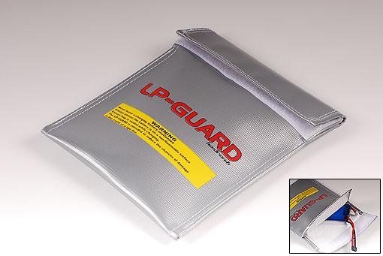 | 1 | 1.99 | Hobby King | EEUU

